**Do LoRa Low-Power Wide-Area Networks Scale?**

LPWANs generally form one-hop networks where every node can reach directly one (or more) Internet connected sink nodes. Network operators see this as beneficial as constructing and maintaining a multi-hop network can be avoided. However, given the fact that LPWANs cover a wide area and that all devices communicate directly to a few sink nodes, a large number of nodes have to share the communication medium. The question arises how many nodes can be operated in the same area without dissatisfying application performance requirements.

In order to be scalable, LoRa provides for a range of communication options-carrier frequency, spreading factor, bandwidth, and coding rate- from which a transmitter can choose. Many settings are orthogonal and provide simultaneous collision free communications. Nevertheless, there is a limit regarding the number of transmitters a LoRa System can support. In this paper, these capacity limits are investigated based on the practical experiment and simulation. The contributions are:

LoRa Link Behavior: Using practical experiments, the model is developed that describes (1) communication range in dependence of communication settings SF and BW and (2) capture effect of LoRa transmissions depending on transmission timings and power.

LoRa Simulator: Designed simulator captures specific LoRa link behavior and enables evaluation of large-scale LoRa networks.

LoRa Scalability Evaluation: Evaluations show that LoRa does not scale well when using it with static settings and a single sink as typically deployed in LoRaWAN. The usage of multiple sinks and dynamic communication parameter settings can produce very scalable solutions.

**LORA**

LoRa is a proprietary spread spectrum modulation technique by Semtech. It is a derivative of Chirp Spread Spectrum with integrated Forward Error Correction. A LoRa receiver can decode transmissions 19.5 dB below the noise floor, so it enables very long communication distances. LoRa key properties are long range, high robustness, multipath resistance, Doppler resistance, and low power. 868 MHz and 433 MHz are often used ISM bands in LoRa technology.

**Transmission Options**

A typical LoRa radio provides five configuration parameters. Energy consumption, transmission range and resilience to noise is determines by the selection of these parameters.

**Transmission Power:** The transmission power range is often limited to 2 dBm to 20 dBm. Because of hardware limitations, power levels higher than 17 dBm can only be used on a 1% duty cycle.

**Carrier Frequency**

**Spreading Factor:** SF is the ratio between the symbol rate and chip rate.

SF Sensitivity(better) and range Time on air

The number of chips per symbol = 2SF

Each increase in SF halves the transmission rate, and doubles transmission duration and energy consumption. SF can be selected from 6 to 12.

**Bandwidth:**

BW Data rate Time on air Sensitivity (worse)

Data is sent out at chip rate equal to the bandwidth. So, a bandwidth of 125 kHz corresponds to a chip rate of 125 kcps. A typical LoRa network operates at 500kHz, 250kHz or 125kHz.

**Coding Rate:** Coding rate is the Forward Error Correction rate that is used by LoRa modem that offers protection against burst of interference. It can be set to 4/5, 4/6, 4/7 or 4/8. A higher CR offers more protection but increases the time on air.

Radios with different CR (and same CF, SF, BW) can still communicate with each other if they use an explicit header as the CR of the payload is stored in the header of the packet.

**Transmissions**

metin içeren bir resim

Açıklama otomatik olarak oluşturuldu**LoRa Packet Structure:**

A packet starts with the preamble, programmable from 6 to 65 635 symbols, to which the radio adds 4.25 symbols.  
An optional header describes the length and FEC rate of the payload and indicates the presence of an optional 16-bit CRC for the payload.

The header is always transmitted with a 4/8 FEC rate and has its own CRC.   
Payload can contain 1 to 255 bytes. At the end of the payload, an optional 16-bit CRC may be included.

**Airtime:** The airtime of a LoRa transmission depends on the payload size and the combination of SF, BW and CR. (Duration can be calculated with Semtech LoRa modem calculator)

Regulatory Constraints in Europe: The license-exempt band usable for LoRa (863MHz to 870MHz) is subdivided in 7(overlapping) subbands. Each subband has specific requirements regarding max ERP (Effective Radiated Power), spectrum access and channel spacing. For the majority of the subbands, the ERP is 25 mW (14 dBm). For spectrum access, there is the option of either using a duty cycle (often ≤0.1) or a Listen Before Talk (LBT) transmission scheme.

**LORA LINK BEHAVIOR**

**Communication Range**

The received signal power Prx:



Prx and Ptx are the received and the transmitted power in dB

Grx and Gtx are the receiver and the transmitter antenna gain in dBi

Lrx and Ltx are the receiver and the transmitter loss in dB

Lpl is the path loss in dB

Lm are various losses (fading margin, other losses)

On the transmitter side, range can only be changed by changing the transmit power. Other parameters like SF, BW and CR don’t influence the radiated power, or any other gains and losses.

On the receiver side, the range is limited by the sensitivity threshold which is influenced by the LoRa parameters SF and BW.

**Path Loss**

The well-known log-distance path loss model which is commonly used to model deployments in built-up and densely populated areas is used in this paper. The path loss in dependence of the communication distance d can be described as:

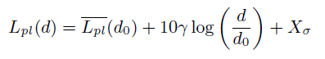

Lpl(d) is the path loss in dB  
Lpl(d0) is the mean path loss in dB at the reference distance d0γ is the path loss exponent Xσ~N (0, σ2), the normal distribution with zero mean and σ2 variance to account for shadowing.

The communication range and exact path loss model is highly dependent on the environment and a generic figure cannot be given.

Using empirical measurements with d0 at 40m, Lpl(d0) is 127.41 dB, γ is 2.08 and σ is 3.57 in the built up environment. These values are used in the simulation but σ=0 is taken.

**Sensitivity**

The sensitivity of a radio receiver at room temperature is given by:



The first term describes thermal noise in 1 Hz of bandwidth and can only be influenced by changing the temperature of the receiver. BW is the receiver bandwidth. NF is the receiver noise figure ,and fixed for a given hardware implementation. SNR is the signal to noise ratio require determined by SF.

As BW is set in steps of powers of 2, we can observe that increasing the BW decreases the sensitivity (worse sensitivity) by 3 dB and vice versa. Similar for SF, increasing the SF doubles the chips per symbol which increases the sensitivity 3 dB. (In this paper increasing sensitivity means -123 dB -> -126 dB e.g.)

tablo içeren bir resim

Açıklama otomatik olarak oluşturulduThe results of the measurements are shown in the table. As expected, decreasing the BW or increasing the SF improve sensitivity. The difference between each step is not 3 dB but more in the range of 0dB to 4dB, and 2 dB average. Probably this is caused by external interference, and hardware limitations other than the radio chip itself.

Using communication range, path loss and sensitivity equations, we can now estimate if a LoRa transmission will be received or not. The decision regarding transmission reception can be formally described as:

metin içeren bir resim

Açıklama otomatik olarak oluşturuldu

Srx is the receiver sensitivity, and depends on the SF and the BW.

**Collision Behavior**

When two LoRa transmissions overlap at the receiver, there are several conditions which determine whether the receiver can decode, one or two packets, or nothing at all. These conditions are Carrier Frequency (CF), Spreading Factor (SF), power and timing.

**Reception Overlap:** Packet *i* reception starts at ai and ends at bi. The midpoint mi = ai + bi /2 and the midpoint length di = ai - bi /2. Two packets, x and y, overlap when their reception intervals overlap, that is:



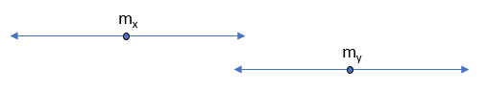

**Carrier Frequency:** When two transmissions overlap in time, but not in CF, they don’t interfere each other and can both be decoded (assuming a receiver is listening at both CFs). The overlap in CF is defined as the absolute difference of these frequencies, and the tolerable frequency offset, which depends on the bandwidth. We can define the condition when two transmissions collide on CF Cfreq as:

saat içeren bir resim

Açıklama otomatik olarak oluşturuldu

fx and fy are the center frequencies of transmission x and y, and fthreshold is the min tolerable frequency offset. It depends on the BW and the LoRa device that is used.

**Spreading Factor:** Transmissions with different SF (and same CR and BW) can be successfully decoded as long as the receiver has two available receive paths. We define the condition on when two receptions collide on SF CSF:

metin içeren bir resim

Açıklama otomatik olarak oluşturuldu

SFx and SFy are the SF of transmission x and y.

**Power:** As LoRa is a form of frequency modulation, it exhibits the capture effect. The capture effect occurs when two signal are present at the receiver and the weaker signal is suppressed by the stronger signal. When the difference in received signals is too small, the receiver keeps switching between the two signals, and not able to decode either transmission. We can define the condition on when packet x collides with packet y on received signal strength as:

metin, saat, kol saati içeren bir resim

Açıklama otomatik olarak oluşturuldu

Px and Py are the received signal strength of x and y respectively. Pthreshold is the power threshold.

**Timing:** The critical section of a packet reception starts at the last 5 preamble symbols, so the interval of the transmission packet x can be redefined as xcs =( ax + Tsymbol *( Npp -5), bx ) where Tsymbol is the symbol time and Npp is the number of programmed preamble symbols. Therefore, packet x collides with packet y when it overlaps in its critical section xcs:

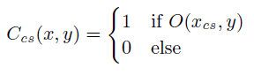

When all conditions as defined below are true, then packet x and packet y collide:

metin içeren bir resim

Açıklama otomatik olarak oluşturuldu

**LORA SCALABILITY  
Simulation Framework:** For the purpose of understanding and examining scalability of LoRa networks, the simulation tool LoRaSim is developed. The LoRaSim is a custom-build discrete event simulator implemented with Simply. LoRaSim allows to place N LoRa nodes in a 2-dimentional space. M LoRa sinks can be also placed within space.

For an experiment, each node’s transmission behavior is described by the average packet transmission rate λ and packet payload B. The preamble length is assumed as 8 symbols. The behavior of a node *n* during simulation run is described by the set SNn= {TP, CF, SF, BW, CR, λ, B}

The communication behavior of LoRa nodes can be modelled using the equations for communication range and collision behavior. However, the simulator has the ability to replace both models with a simplified variant. The simplified variant assumes infinite communication range and any two transmissions overlapping in time at the receiver with the same CF, SF and BW will collide and none of the two transmissions is received.

**Evaluation Metrics:** Two evaluation metrics are used: Data Extraction Rate (DER) and Network Energy Consumption (NEC). DER can be defined as the ratio of received messages to transmitted messages over a period of time. The achievable DER depends on the position, number, and behavior of LoRa nodes and sinks which is defined by N, M and SN. The metric is a metric looking the network deployment as whole. NEC can be defined as the energy spent by the network to successfully extract a message. The NEC depends on the number of nodes, frequency of transmissions and transmitter communication parameters (SF, BW, CR->transmission duration). It is a metric looking at the network deployment as whole.

**Experimental Evaluation**

**Experiment Set 1-Single Sink:** N nodes transmit to one sink (M=1). For an experiment run all nodes use the same configuration set SN= {TP, CF, SF, BW, CR, λ, B}. Nodes are placed randomly around the sink ,and can reach the sink with the given setting SN. We compare the three transmitters. 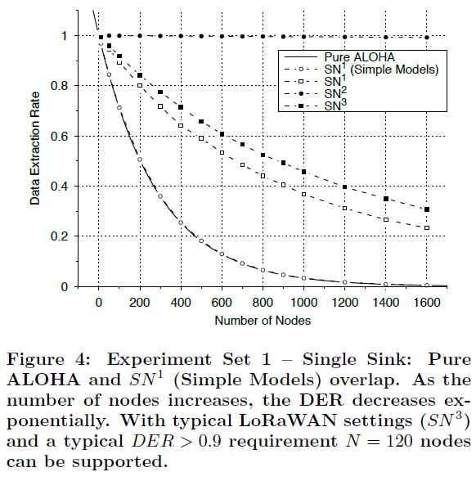tablo içeren bir resim

Açıklama otomatik olarak oluşturulduconfigurations. We assume a 20-byte packet is sent by each node every 16.7 min.

With SN1 the most robust LoRa tx settings are chosen that lead the longest possible airtime. With SN2 the transmission settings lead to the shortest airtime. SN3 is the setting used by common LoRaWAN deployments. SN1 is used with simple channel model and LoRa channel model described above to analyze the impact of the model.

With an increasing number of nodes, the DER drops exponentially in all cases. The difference in DER is significant when comparing the configuration with longest and shortest airtime.  
We can also observe a significant difference between the simple channel model and the LoRa channel model. The modelled communication range here is around 100m.

One could use less conservative tx settings (SN2) to accommodate more nodes. However, in this case the transmission range is reduced and little protection against burst interference is provided.   
  
If the deployment is located in Europe, each node would only use the channel for 0.1% of the time (duty-cycle limitation). With SN3 we obtain a channel duty-cycle of 0.13% that is above the regulator allowance. To comply, it is needed to reduce the data tx rate from one 20 byte packet every 16.7 min to every 22 min.

The more realistic channel model leads to an increase in DER as colliding transmissions may still be received due to capture effect.

The setup with simple channel models corresponds to Pure ALOHA. The DER for such system is:



N=the number of nodes. Tpacket is the packet time on air. λ is the transmission rate of all nodes. Figure shows for SN1 simulation results together with analytic solution that match closely. This analytic solution can be used to describe the DER worst-case bound. More realistic channel models always result in a performance boost due to the capture effect.

**Experiment Set 2-Dynamic Parameters:** M=1. Three transmitter configurations SN3, SN4, SN5 are compared. Nodes are randomly placed around the sink within a radius that ensures that all nodes can reach the sink if they use the most robust settings. For each node, the BW, SF, CF are set such that airtime is minimized. First airtime and then transmission power is minimized. (SN4 with constant TP=14 dBm)

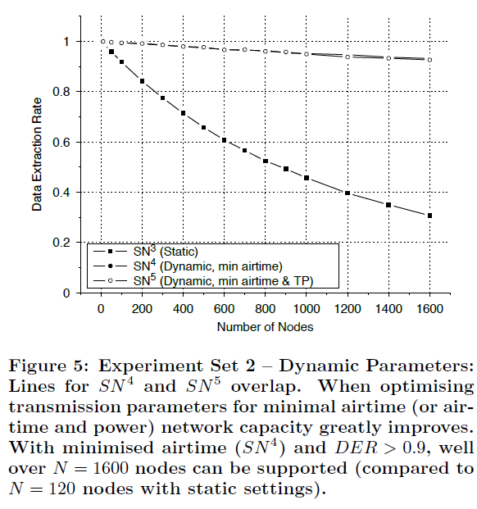The optimal allocated settings in terms of airtime (plus TP) have a huge impact on achievable DER. With minimized airtime (SN4) and DER>0.9 requirement, over N=1600 nodes can be supported. This is a dramatic improvement compared to N=120 nodes achieved with static conservative settings as used in LoRaWAN.

However, it has to be considered that this achievement is not practical and relies on quite optimistic assumptions. First, the simulation doesn’t consider interference and a minimum airtime setting has a low CR setting which does not provide sufficient protection. Second, the setting would need to be re-evaluated from time to time due to environmental changes.

Choosing settings with shorter airtime and less TP will not only help to improve DER but helps to achieve significant energy savings.

**Experiment Set 3-Multiple Sinks:** In this experiment, the impact of the number of sinks M is investigated. The previously described setting SN1 is used for each experiment run. For each run, increasing number of sinks M is used.

The node placement strategy is changed as now multiple sinks are present. (dmax max transmission range, dmax = ymax, xmax=30.5 dmax) This setup ensures that with given communication settings SN1 nodes can reach at least one sink. This sink placement strategy is chosen for simplicity rather than optimality.

The results show that increasing the number of sinks significantly increases the DER.

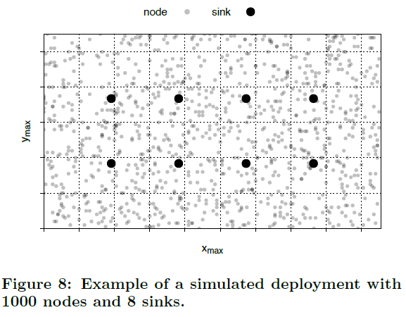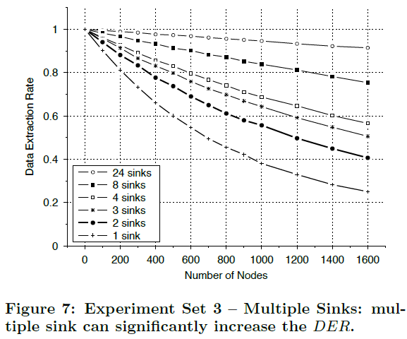

**Findings:**

* Lower-Bound on Performance: Pure ALOHA represents a good DER lower-bound in single sink deployments. DER equation for ALOHA can be used to quickly estimate expected performance of a typical LoRaWAN deployment.
* LoRaWAN Scalability: With typical LoRaWAN settings (SF12, 125kHz BW, CR 4/5) the assumption of a 20-byte packet is sent by each node every 16.7 and a DER>0.9 requirement, N=120 nodes can be supported. This is not a sufficient number for apps.
* Dynamic LoRa Settings: Dynamic settings has a tremendous impact on the network scalability. However, protocols and mechanisms for dynamic parameter selection are required.
* Capture Effect: The capture effect has a significant impact on achievable DER. By far, not all colliding transmissions are lost, in many situations at least one of the colliding transmissions can be received successfully.
* Multiple Sinks: Adding additional sinks improves DER. A saturation or an upper bound below 1 have not been observed. (The reason for these is the capture effect. With increasing sinks, the changes of nodes to find a sink is increases)